E-Commerce Store
Final Year Project
Session 2018-2022

A project submitted in partial fulfillment of the degree of
BS in Computer Science


Department of Computer Science
Faculty of Computer Science & Information Technology
Superior University, Lahore

FALL 2022

Type (Nature of project) |  |  | [ ✓ ] Development [ ] Research [ ] R&D
Area of specialization
FYP ID |  |  | FYP-BCSM-F21-052
Project Group Members
Sr.# | Reg. # | Student Name |  | Email ID |  | *Signature
(i) | BCSM-F18-261 | Mustafa |  | bcsm-f18-261@superior.edu.pk
(ii) | BCSM-F18-269 | Hannan Haider Farooq |  | bcsm-f18-269@superior.edu.pk
(iii) | BCSM-F18-322 | Muhammad shahroz |  | bcsm-f18-322@superior.edu.pk
*The candidates confirm that the work submitted is their own and appropriate credit has been given where reference has been made to work of others

Plagiarism Free Certificate
This is to certify that, I Hannan Haider Farooq S/D of Abdul Majeed, group leader of FYP under registration no FYP-BCSM-F21-052 at Computer Science Department, The Superior College, Lahore. I declare that my FYP report is checked by my supervisor.
Date: Name of Group Leader: Hannan Haider Farooq Signature: _____________
Name of Supervisor: Co-Supervisor:
Designation: Lecturer Designation: Associate Professor
Signature: ________________ Signature: _________________

HoD: Dr. Arfan Jaffar
Signature: _______________

Project Report
[Circuit Supplyers]

Change Record
Author(s) | Version | Date | Notes | Supervisor’s Signature
 | 1.0

APPROVAL

PROJECT SUPERVISOR
Comments: ___________________________________________________________________
_____________________________________________________________________________

Name:______________________________
Date:_______________________________ Signature:__________________________

PROJECT MANAGER
Comments: ___________________________________________________________________
_____________________________________________________________________________

Date:_______________________________ Signature:__________________________

HEAD OF THE DEPARTMENT
Comments: ___________________________________________________________________
_____________________________________________________________________________

Date:_______________________________ Signature:__________________________

Dedication

This work is dedicated to our parents who provide us the opportunities and support us to learn and do everything we want. Moreover, we want to dedicate our work to our supervisor, Ma’am Arshia Naeem, who taught us well in the semester and enabled us to do this project. Also, we want to dedicate this work to our institute (Superior college Gold campus, Lahore), which is providing us so much opportunities to polish our skills.

Acknowledgments

It is by the Grace of Allah Almighty, the Lord, and Creature of this Universe. Whose power and Glory all things are accomplished and his Prophet (P.B.U.H) who is, forever, a torch of guidance and knowledge for humanity as whole. We thank to Allah Almighty who made it possible for us to complete this project and to overcome all the difficulties faced during the course of this project. We would like to pay our thanks to our project supervisor PROF. ARSHIA NAEEM Lecturer at Superior University for specialist advice and support. It was due to his knowledge and skill that we were able to handle problems faced during the project. His kind, accommodating, Suggestions Constant Encouragement and generous supervision made this project easy for us. We would also like to thank all the teachers of computer science and IT department who helped us a lot during all the semesters we have studied so far and assisted us at becoming good computer scientists. We are also grateful to our family for their help and support when we needed it the most.

Executive Summary
In the present quick changing business climate, it's critical to have the option to answer client needs in the best and convenient way. For example, your clients may wish to see your business on the web and want to know about your offered services or products.
Shopping virtually is a way of life in which e-commerce web-based application retails different style and various items of living. This application permits seeing different available items, empowering enlisted clients to buy required items promptly by utilizing different methods of payments, and furthermore can submit a request by utilizing the “Cash on Delivery (Pay Later)” choice. This application enables Administrators and Managers to see the placed orders with the choice of advance payment or cash on delivery.
To run an online business site, various Technologies should be considered and perceived. These incorporate multi-layered design, server, and client-side prearranging methods, and executing innovations like React.JS, Node.JS, and social data sets. This is a task with the goal to foster a fundamental site where a shopper is given a shopping basket application and furthermore to learn about the innovative technology used to run such an application.
This assignment will talk about every required fundamental technology to make and carry out an internet business site application and also to know about the technologies used to develop such an application.

List of Figures

1.1 Caption of first figure of first chapter 6
1.2 Caption of second figure of first chapter 7
2.1 Caption of first figure of second chapter 14
2.2 Caption of second figure of second chapter 22
2.3 Caption of third figure of second chapter 26
5.1 Caption of first figure of fifth chapter 49
5.2 Caption of second figure of fifth chapter 49

List of Tables

1.1 label of first table of first chapter 6
1.2 label of second table of first chapter 7
2.1 label of first table of second chapter 14
2.2 label of second table of second chapter
22 2.3 label of third table of second chapter 26
5.1 label of first table of fifth chapter 49
5.2 label of second table of fifth chapter 49

Table of Contents
Chapter 1 12
1.1. Background 14
1.2. Motivations and Challenges 14
1.3. Goals and Objectives 15
1.4. Proposed Solution 15
1.5. Project Plan 16
Chapter 2 20
Chapter 2: Software Requirement Specifications 21
2.1. Introduction 21
2.2. Overall Description 23
2.3. External Interface Requirements 25
2.4. System Features 26
2.5. Other Nonfunctional Requirements 27
2.6. Other Requirements 28
Chapter 3 29
Chapter 3: System Analysis 29
3.1. Use Case Model 30
3.2. Use Case Descriptions 30
Chapter 4 40
Chapter 4: System Design 41
4.1. Architecture Diagram 41
4.2. Domain Model 42
4.3. Entity Relationship Diagram with data dictionary 42
4.4. Class Diagram 43
4.5. Sequence / Collaboration Diagram 44
4.7. Activity Diagram 48
4.8. State Transition Diagram 57
4.9. Component Diagram 58
4.10. Deployment Diagram 59
4.11. Data Flow diagram 59
Chapter 5 61
Implementation 61
5.2. Components, Libraries, Web Services and stubs 62
5.3. Deployment Environment 62
5.4. Tools and Techniques 62
5.5. Best Practices / Coding Standards 63
5.6. Version Control 63
Chapter 6 64
6.1 Use Case Testing 65
6.1.1 Equivalence partitioning 65
6.1.2 Boundary value analysis 65
6.2 Data flow testing 66
6.3 Unit testing 66
6.4 Integration testing 66
6.5 Performance testing 67
6.6 Stress Testing 67
Chapter 7 68
7.1 Project Summary 69
7.2 Achievements and Improvements 69
7.3 Critical Review 70
7.4 Future Enhancements/Recommendations 70

Chapter 1
Introduction

Chapter 1: Introduction
Now a days many people around the world used to shopping online sites like “Amazon”, “Alibaba” or “Daraz” etc... because these are the biggest online shopping platform. In Amazon customer can schedule the delivery of desired product with “Amazon Day”, Customer purchase Amazon credit with NoRush delivery, Customer can protect his cash with “Amazon Warehouse, and Amazon Outlet”, Customer also claim for money back offer when packages did not arrive on time, and Customer can also get discounts with Subscribe & Save.
The world we see today is becoming more and more digital. In this digitized world, e-commerce is taking over by bringing products within reach of customers where the customer no longer has to leave the house. As people today depend on products online, the importance of a review is becoming increasingly important. To select a product, a customer has to go through thousands of reviews to understand a product. But in this thriving day of machine learning, it would be much easier to search through thousands of reviews if a template were used to polarize and learn from those reviews. We used the guided learning method on a large-scale Amazon dataset to polarize it and achieve satisfactory accuracy. (Haque, 2018, May)
Developments in the digital marketing have pushed manufacturers, especially those in the “information technology (IT)” business, to invent goods that customers can modify to meet their own specific requirements. This study observes the strategies of companies to offer such customizable products to consumers. Our analysis shows that a monopoly company gains more profit by presenting a personalized item to the consumer rather than by selling a homogenous product that is pre-configured only if the customers are adequately able to perform the job of personalization; rather than it is more lucrative for the company to offer a homogenous product. In addition, customers get a larger surplus in case the company offers personalized products. We likewise consider the situation where the organization can offer both a versatile item and a normalized item and find that the organization make more profit from offering the two items than from offering either item, as the flexibility and the customer variation costs are not excessively high. Strangely, when the organization offers the two items, its endeavors to further develop buyer personalization (e.g., offering free training of customers) consistently benefit both the organization and purchasers. (Gu, 2015)
In our site we will provide fully customer support so it will be easy for customer to interact with our sites, we will also provide standardized product and customizable products as the customer can also customize his products and customer can also see a 3D model of his design. And it will also easy for him to select a good design for his shirt.

1.1. Background
There were millions of People in the current era who do online shopping from different websites, and they got scams because many websites are not registered and many times, they even not get what they ordered for, and if they get the ordered thing, they face size issue many times.
Our website will solve all these problems as our website will secure and will be a registered shopping store where customers can purchase not only their dresses but also they can design them according to their own wishes and color combinations. In this way they will design their own unique dress and they will give their real size of dress so there will be no issue of sizes when the customer get their dress. Our website will also provide easily instant payment method and will also provide cash on delivery. So, it will be easy for customer to pay their dues. (RAZIF, 2018)

1.2. Motivations and Challenges
Nowadays, many e-commerce websites provide online shopping for their customers. Many ecommerce websites, provide the same type of products for customers and have fixed sizes whether they fit their customers or not and customers have no other choices for their dress and he/she has to adjust with the size too and sometime they complete with their order and purchase anything from different website with online payment then they get scam by that website because that website was not secure but our website will be secure and in our website customer can purchase anything from our store and if he/she could not find anything according to his/her will then he/she can design his/her dress according to own wish, after designing that customer will give his perfect size for their dress and can go for payment method like instant payment method and can also elect cash on delivery as he will pay when he get his dress. So, In this way we can fulfill the customers wishes.

1.3. Goals and Objectives
In our E-Commerce Store, Every vendor will provide special customization for customers so every customer will design his/her products. All customization will happen in front of the customer in a 3D image, So, the customer will also get a 3D view of his product that will help him to design his product and see the changes in the product, and after completing the customization the customer will give his perfect size for their dress and can go for payment method like instant payment method and can also elect cash on delivery as he will pay when he gets his dress. So, In this way, we can fulfill the customer's wishes.

1.4. Proposed Solution
In our E-Commerce Store Every vendor will provide special customization for customer so every customer will design his/her products. All customization will happen in front of customer in a 3D image, So, the customer will also get a 3D view of his product that will help him to design his product and see the changes in the product.
For example, a customer has to purchase a Pant and the customer is very healthy, So, its size will not be easily available in others online store but in ours store he not only get the size of his pants, he also customizes his pant according to his favorite color and design.
In this way, every customer will get his/her favorite product according to his wish. And every vendor will have different designs so the customer will have lots of design and customer will also customize that design according to his wish.

1.5. Project Plan
The arrangement of doing the project depended on a steady model which was essentially founded on a strategy of doing things bit by bit. We expected to construct the initial part of our task and afterward we would conclude that what to do next then. To start with, we expected to characterize the necessities of our undertaking then to affirm that these were the main prerequisites or we could have more from here on out. As we have only 2 members in our group and we have to achieve the goal of completion of our project, we would give responsibilities to each of the members of this group and these responsibilities will be monitored by our project leader Mr. Hannan Haider Farooq.
Monitoring the members was such an important task that we needed to conduct meetings on daily basis. So that, if there was any problem in the tasks and responsibilities, we needed to solve those problems by providing suitable solutions in a very short period of time.

1.5.1. Work Breakdown Structure

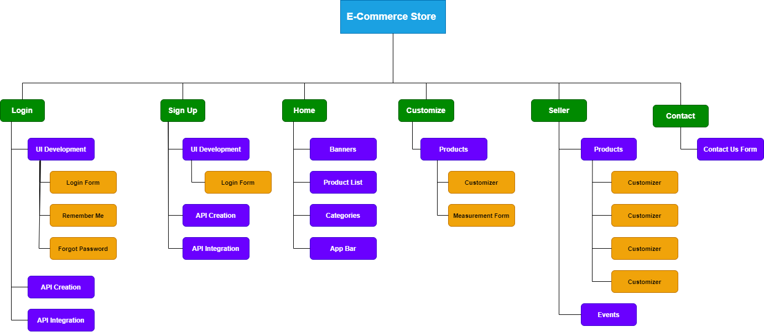

1.5.2. Roles & Responsibility Matrix
WBS # | WBS Deliverable | Activity no. | Activity to | Duration | Responsible
 |  |  | Complete the | (no. of Days) | Team
 |  |  | Deliverable |  | Member(s) & his  Role(s)
01 | Requirement collection | 1.0 |  | 6 | All of us
02 | System Design | 1.1 |  | 7 | Hannan Haider Farooq,
 | flow |  |  |  | Mustafa
03 | Database design | 1.2 |  | 4 | All of us
04 | Database | 1.3 |  | 2 | Mustafa,
 | implementation |  |  |  | Hannan Haider  Farooq
05 | GUI design | 1.4 |  | 5 | Mustafa
06 | GUI & Database  Integration |  |  | 4 | All of Us
07 | Coding | 1.5 |  | 10 | All of us
08 | Bug Fixing | 1.6 |  | -- | M Sheroz,  Mustafa
09 | Final Testing | 1.7 |  | 2 | All of Us

Chapter 2
Software Requirement
Specifications

Chapter 2: Software Requirement Specifications

2.1. Introduction

2.1.1. Purpose

The web application is expected to give total package for merchants as well as clients through a solitary entryway involving the web as the sole medium. It will empower sellers to set up internet-based shops, clients to peruse the shop and buy them online without visiting the shop actually. The organization module will empower a framework director to support and reject demands for new shops and keep up with different arrangements of shop classifications.

2.1.2. Document Conventions
- Entire document should be justified ▪ Convention for main title:
  - Font Face: Times New Roman. o Font Style: Bold.
  - Font Size: 32.
- Convention for sub title:
  - Font Face: Times New Roman. o Font Style: Bold.
  - Font Size: 32.
- Convention for body:
  - Font Face: Times New Roman. o Font Style: Normal.
  - Font Size: 11.

2.1.3. Intended Audience and Reading Suggestions
- Consumer
- Web developers
- _{Designers}
- _{All Users}

2.1.4. Product Scope
  - Secure enlistment and profile set up for Customers

Sufficient scanning components for simple and speedy admittance to specific items and offered services.

Making a Shopping cart so clients can shop 'n' no. of things and checkout at last with the whole shopping baskets. Clients can add or erase things in the selected cart.

Customary updates to enlisted clients regarding the OFS (Offer for Sale) about fresh stock.

Transferring 'Most Purchased' Items in every class of items in the Shop.

Vital information and diagrams for Administrators and Shop proprietors about the things that are best selling in every classification and age bunch.

Keeping up with data set of normal clients of various necessities.

Shop representatives are liable for inner matters like handling orders, confirming home delivery of the products, getting client's feedback regarding order processing time, refreshing request's status and noting client's inquiries on the web.

Client feedback component, so clients can express their experience for the item or administration which they have bought. Additionally, monitor the rating of individual items by significant clients.

Sufficient payment system and gateway for all famous Visas, and other pertinent choices for payments, as accessible over time.

2.1.5. References
- React JS: (reactjs.org/)
- Node JS: (nodejs.org/)
- MySQL: (dev.mysql.com)

2.2. Overall Description

2.2.1. Product Perspective
E-Commerce Store is pointed towards the sellers who need to connect with the greatest cross segment of client and average folks who can be possible client. This task imagines overcoming any issues between the dealer, the retailer and the client. OFS ought to be easy to use, 'speedy to learn' and solid programming for the above reason. OFS is planned to be an independent item and shouldn't rely upon the accessibility of other programming. It ought to run on both UNIX and Windows based stage.

2.2.2. Product Functions

The principal reason for this venture is to decrease the manual work.

A Customer can peruse the shops and pick items to put in a virtual shopping basket. The shopping basket subtleties can be seen and things can be taken out from the cart. To continue with the shopping, the client is incited to login. Likewise, the client can alter individual profile data, (for example, telephone number and transportation address) put away by the application. The client can likewise see the situation with any past orders, and drop any request that has not been transported at this point.

2.2.3. Client Classes and Characteristics
- The client ought to be know all about the shopping mall related wording like Shopping cart/Checking out/Transaction and so on.
- The client ought to be know about the Internet.

2.2.4. Working Environment
The item will be working in windows climate. E-commerce Store is a site which will work in every renowned program, for a model we are talking Microsoft Internet Explorer, Google Chrome and Mozilla Firefox. Likewise, it will be viable with the IE 6.0. The vast majority of the elements will be viable with the Mozilla Firefox and Opera 7.0 or higher variant. The main prerequisite to utilize this web-based item would be the web association. The hardware configuration includes Hard Disk: 40GB, Monitor: 15-inch Color monitor, Keyboard: 122 keys. The basic input devices required are keyboard, mouse and output devices are monitor etc.

2.2.5. Design and Implementation Constraints
A web-based store is a virtual store on the Internet where clients can peruse the index and select results of interest. The chose things might be gathered in a shopping basket. At checkout time, the things in the shopping basket will be introduced as a request. Around then, more data will be expected to finish the exchange. Typically, the client will be approached to fill or choose a charging address, a transportation address, a delivery choice, and payment data, for example, Visa number. An email warning is shipped off the client when the request is set.

2.2.6. User Documentation
The item will incorporate client manual. The client manual will incorporate item outline, complete arrangement of the pre-owned programming (like SQL server), specialized subtleties, reinforcement methodology and contact data which will incorporate email address. There will be no internet-based help for the item right now. The item will be viable with the Internet Explorer 6.0 or higher. The data sets will be made in the MySQL.

2.2.7. Assumptions and Dependencies
The assumptions are:
- The coding ought to be sans mistake.
- The framework ought to be easy to understand so it is not difficult to use for the clients.
- The framework ought to have greater limit and give quick admittance to the data set.
- The framework ought to give search office and backing speedy exchanges.
- The E-Commerce Store is running 24 hours per day.
- Clients might access from any PC that has web perusing capacities and a web association.
- Client should have their right usernames and passwords to go into their internet based accounts and do activities.
The dependencies are:
- The particular equipment and programming because of which the item will be run.
- Based on posting necessities and determination the task will be create and run.
- The end clients (administrator) ought to have appropriate comprehension to the item.
- The framework ought to have the general report store.
- The data, everything being equal, should be put away in a data set that is open by the ECommerce Store.

2.3. External Interface Requirements

2.3.1. User Interfaces
- Administrator can View, Edit and Delete everything on the item.
- Client can see entire site
- Likewise add the item in their cart

2.3.2. Hardware Interfaces
- Working framework : Windows, MacOS, Linux
- Hard circle :40 GB RAM: 512 MB.
- Processor : Pentium(R)Dual-center CPU

2.3.3. Software Interfaces
- PgAdmin
- VS Code
- PyCharm

2.3.4. Communications Interfaces
The Customer should associate with the Internet to get to the Website:
- Dialup Modem of 52 kbps
- Broadband Internet
- Dialup or Broadband Connection with an Internet Provider

2.4. System Features
- The site authority ought to guarantee the client give genuine item
- Client assistance is accessible from the power
- Client data security affirm.
- Oversee client data.
- To build effectiveness of dealing with the power work.

2.5. Other Nonfunctional Requirements

2.5.1. Performance Requirements

There is no presentation prerequisite in this framework in light of the fact that the server solicitation and reaction is relied upon the end client web association.

To keep an OK speed at greatest number of transfers permitted from a specific client as quite a few clients can admittance to the framework whenever. Additionally the associations with the servers will be founded on the characteristics of the client like his area and server will be working 24X7 times.

Clients need 16 Mbps of download speed to work our site.

2.5.2. Safety Requirements
The information base might get squashed at a specific time because of infection or working framework disappointment. There for it is expected to take the data set reinforcement so the data set isn't lost. Legitimate UPS/Inverter office ought to be there in the event of force supply disappointment.

2.5.3. Security Requirements
➢ Framework will utilize got information base.
➢ Typical clients can just understand data yet they can't alter or change anything aside from their own and another data
➢ Framework will have various kinds of clients and each client approaches requirements.

2.5.4. Software Quality Attributes
➢ There might be different administrator's making the task, every one of them will reserve the option to make changes to the framework. Be that as it may, the individuals or different clients can't do changes.
➢ The task ought to be open source
➢ The nature of the data set is kept up with in such a manner so it tends to be extremely easy to understand to every one of the clients of the data set

2.5.5. Business Rules
Kindly allude to our security strategy to figure out our circumstances on this issue. That strategy is likewise material to your meeting on our site.
All the data posted on Switch Techsuch as explanation, chart, sign, button symbol, picture, sound archive sections, advanced download, information alter and programming have a place with the property of Switch Techor its partnered organizations or asset providers, under the security of Chinese and International Copyright Law.
The assemblage of all the data on our site is the selective property of Switch TechInc., under the insurance of Chinese and International Copyright Law.
All the product utilized by Switch Techbelong to the property of Switch TechInc. or on the other hand its associated organizations or asset providers, under the assurance of Chinese and International Copyright Law.

2.6. Other Requirements
E-Commerce Store will deal with expected and non-expected mistakes in manners that forestall misfortune in data and long free time period.

Chapter 3
Use Case Analysis

Chapter 3: System Analysis
This chapter consists of use case, use cases and fully dressed usage of case modeling, that is frequently utilized to model interactions between a system and external actors (users or other systems)

3.1. Use Case Model

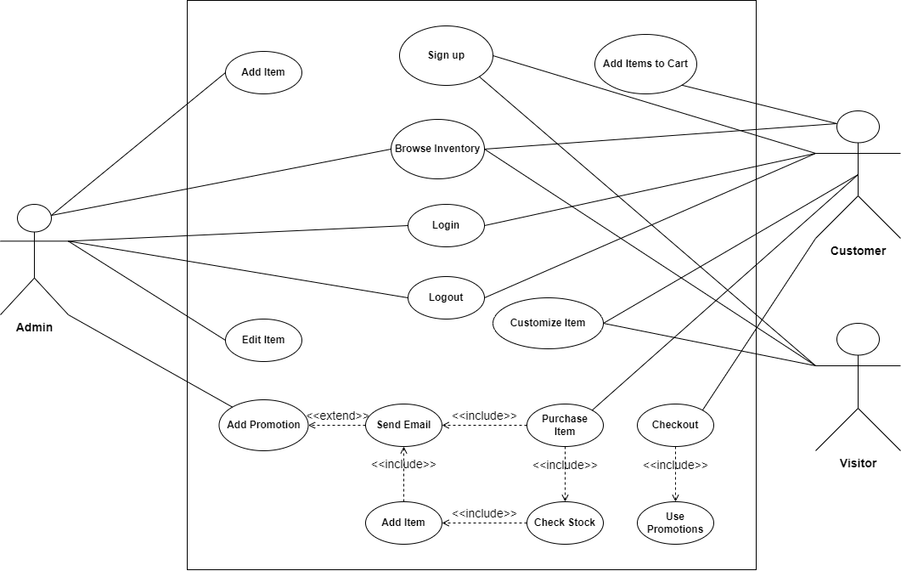

Use Case Descriptions
- Register New User

Use Case ID | UC_01
Use Case Name | Register New User
Description | This use case describes the process of registering a new user for more options on web application.
Primary Actor | User
Secondary Actor | System
Pre-Condition | User should have a little knowledge of computer system.
Post-Condition | New user or customer registered successfully.
Basic Flow | Actor Action | System Action
 | Step1: Click on signup button.  Step2: Fill the form fields.  Step3: Click on submit button. | Step1: Signup page will be displayed.  Step2: Fetch data from form fields.  Step3: Register new user successfully.
Alternative Flow | The user is already registered.  The user is with incomplete information. | Show the message error.  Ask the user to complete the missing information

- Login

Use Case ID | UC_02 Login
Use Case Name | Login
Description | A user can login to the system by entering username and password.
Primary Actor | User
Secondary Actor | System
Pre-Condition | Customer has open the site successfully or admin has open the site successfully.
Post-Condition | User logs in successfully to web application  Admin login successfully to website.
Basic Flow | Actor Action | System Action
 | Step1: This use case is initiated when the admin opens site or user clicks on sign in button.  Step2: User or admin enter the password and username.  Step3: User then click sign in button | Step1: Sign in page will be displayed.  Step2: Validate the data  Step3: User record shown to user.
Alternative Flow | Wrong username or password. | Invalid user.

- Add to Cart
Use Case ID | UC_03
Use Case Name | Add to Cart
Description | The user can add their favorite products to their shopping cart.
Primary Actor | User
Secondary Actor | System
Pre-Condition | User should have internet connectivity to visit the website and add items to cart
Post-Condition | Item added to shopping cart successfully.
Basic Flow | Actor Action | System Action
 | Step1: Click on the shop button.  Step2: Click on add to cart button  Step3: View your product on shopping cart. | Step1: The shop page is loaded.  Step2: Favorite product is added to cart.  Step3: Cart is loaded and item is shown to user.
Alternative Flow | User don’t have internet connectivity. | No shopping cart will be displayed.

- Remove Product From Cart
Use Case ID | UC_04
Use Case Name | Remove Product form cart.
Description | The user can remove added product from cart.
Primary Actor | User
Secondary Actor | System
Pre-Condition | User should have internet access to open the website and the user added the product in the cart.
Post-Condition | The item is deleted from the cart.
Basic Flow | Actor Action | System Action
 | Step1: the user selects the item.  Step2: Click on delete button | Step1: Item selected.  Step2: Successfully deleted the selected item.
Alternative Flow | Wrong username or password. | Invalid user.

- View Product
Use Case ID | UC_05
Use Case Name | View Products
Description | The user can view the products of their choice.
Primary Actor | User
Secondary Actor | System
Pre-Condition | The user has internet access to open the website.
Post-Condition | The products list is shown to the user.
Basic Flow | Actor Action | System Action
 | Step1: The website is opened in the computer.  Step2: The customer clicks on the shop button  Step3: The drop down menu with new products and used products option is showed to user. | Step1: Website loaded to customer’s computer  Step2: A dropdown menu is shown to user  Step3: The system waits for user’s choice for the drop down list.
Alternative Flow | No Internet Access | Website name is not entered correctly.

- Logout
Use Case ID | UC_06
Use Case Name | Logout
Description | The user can close their account by simply clicking on signout button.
Primary Actor | User
Secondary Actor | System
Pre-Condition | User should be logged in before to use this option.
Post-Condition | Logged out from the system successfully.
Basic Flow | Actor Action | System Action
 | Step1: Click on signout button. | Step1: Hide user details imeediately.
Alternative Flow | User is not logged in | Tell user you are not logged in.

- Payment
Use Case ID | UC_07
Use Case Name | Payment selection
Description | User selects the payment selection method to pay the company
Primary Actor | User
Secondary Actor | System
Pre-Condition | User must be logged into the website
Post-Condition | Payment of cart is paid to the company and order number is sent via email to the customer.
Basic Flow | Actor Action | System Action
 | Step1: Open the website  Step2: Completes shopping on the website and then provides billing information to the company  Step3: Selects the payment method to pay company for checkout completion. | Step1: Website home page is shown.  Step2: Billing information saved to the database of the company.  Step3: Payment received confirmation email sent to customer for verifying the payment and order is sent via sms to the customer.
Alternative Flow | Checkout selection. | Cash on delivery confirmed.

- Add Product
Use Case ID | UC_08
Use Case Name | Add New product
Description | Seller can add new product to the website.
Primary Actor | Seller
Secondary Actor | System.
Pre-Condition | Seller is logged into the website.
Post-Condition | Seller successfully adds new product in the stock.
Basic Flow | Actor Action | System Action
 | Step1: Login to the dashboard using Seller credentials.  Step2: Click on Products.  Step3: Click on Add new product.  Step4: Save Product. | Step1: Dashboard returned to the user.  Step2: Products dropdown menu is displayed.  Step3: create new product page displayed.  Step4: Show success message.
Alternative Flow | Invalid | Invalid.

- Update Product
Use Case ID | UC_09
Use Case Name | Edit Product
Description | Seller can edit information of the product.
Primary Actor | Seller
Secondary Actor | System
Pre-Condition | Logged in as Seller
Post-Condition | Product information is updated successfully.
Basic Flow | Actor Action | System Action
 | Step1: login to admin panel.  Step2: Click on view products  Step3: Click on Edit | Step1: Verify the user and return the dashboard.  Step2: Products are displayed on the screen.  Step3: Editable product information is displayed on screen.
Alternative Flow | Seller not Authenticated | Error 404 not found.

- Delete Product
Use Case ID | UC_10
Use Case Name | Delete Product
Description | Seller logs into the system to delete the product.
Primary Actor | Seller
Secondary Actor | System
Pre-Condition | Seller logs into the website successfully.
Post-Condition | Product Deleted from the website.
Basic Flow | Actor Action | System Action
 | Step1: Login to the system using Seller credentials.  Step2: Click on Products.  Step3: Click on view products.  Step4: Click on delete product. | Step1: Verify if the user is Seller or not and prompt it to dashboard.  Step2: Products dropdown menu showed.  Step3: All products in stock are displayed.  Step4: Product removed from the stock.
Alternative Flow | Wrong username or password. | Invalid user.

Chapter 4
System Design

Chapter 4: System Design
- Use Case Diagram
- Architecture Design
- Domain Model
- Entity Relationship Diagram
- Class Diagram
- Sequence / Collaboration Diagram
- Activity Diagram
- Component Diagram
- State Transition Diagram
- DFD Diagrams

4.1. Architecture Diagram
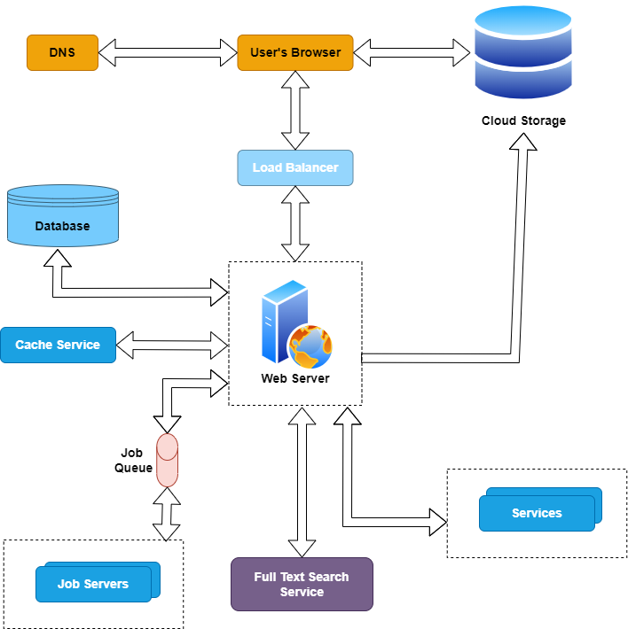

4.2. Domain Model
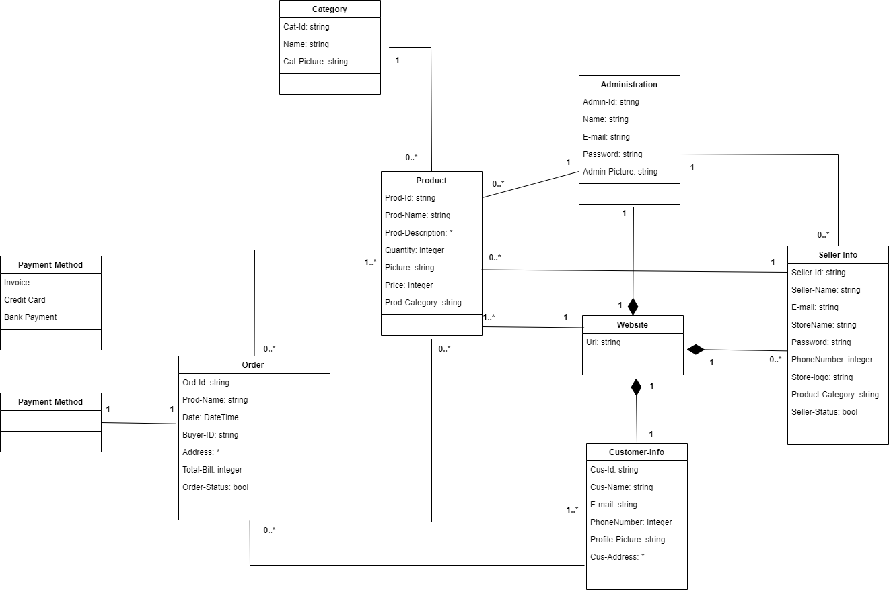

4.3. Entity Relationship Diagram with data dictionary
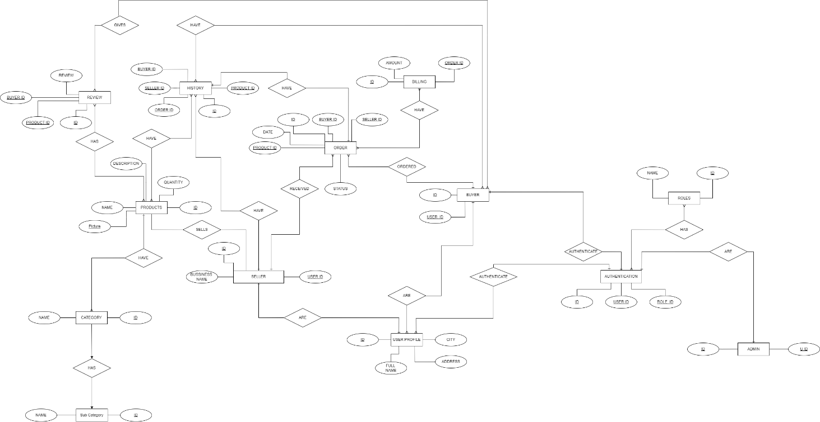

4.4. Class Diagram
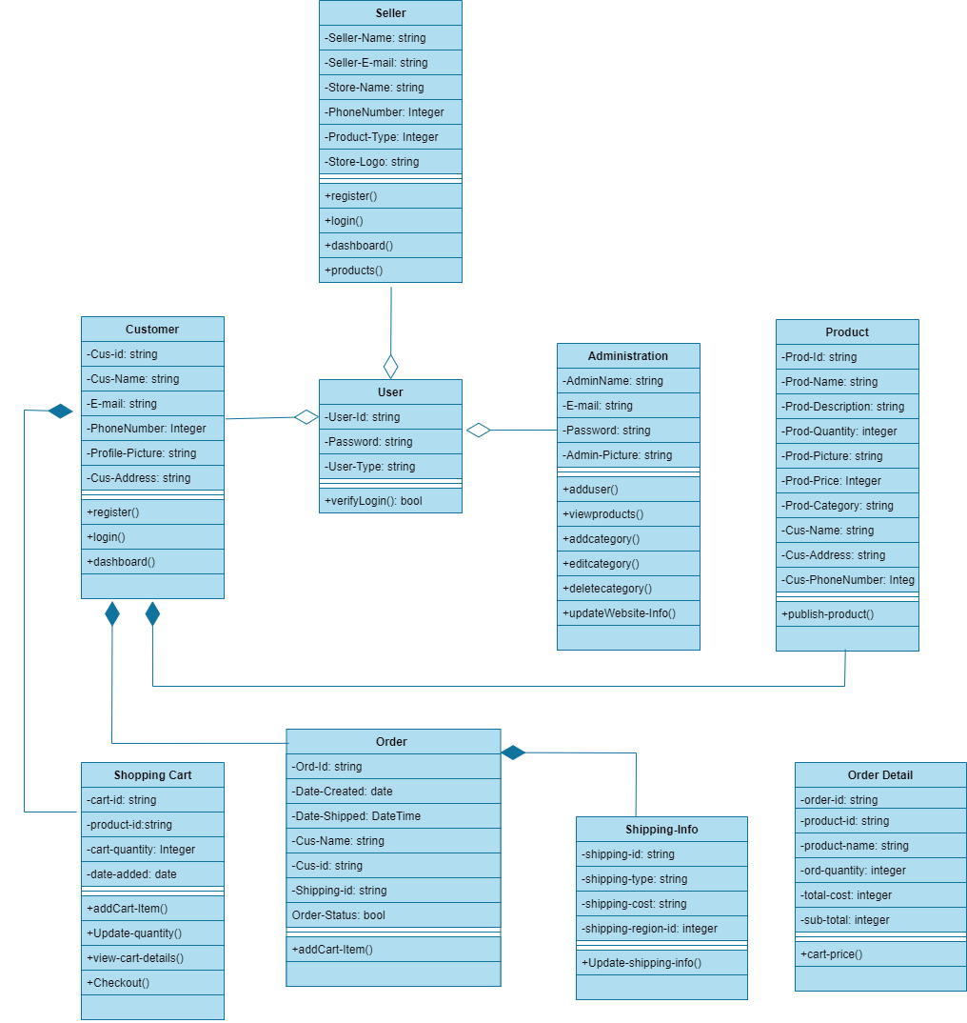

4.5. Sequence / Collaboration Diagram
- Registration
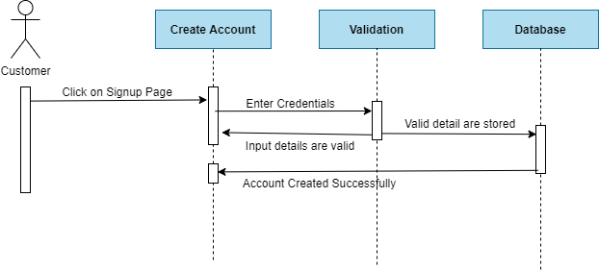
- Login
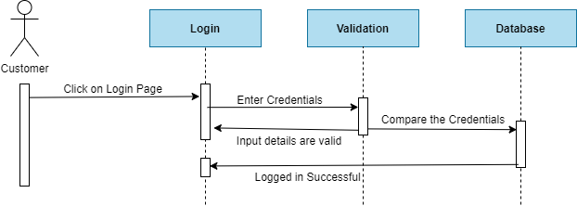
- Place order
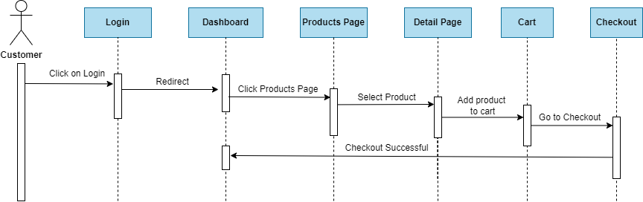
- Customization
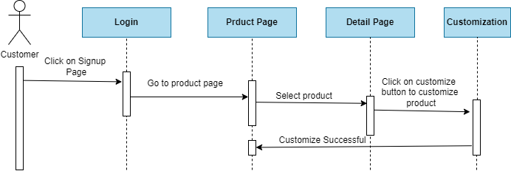

- Payment
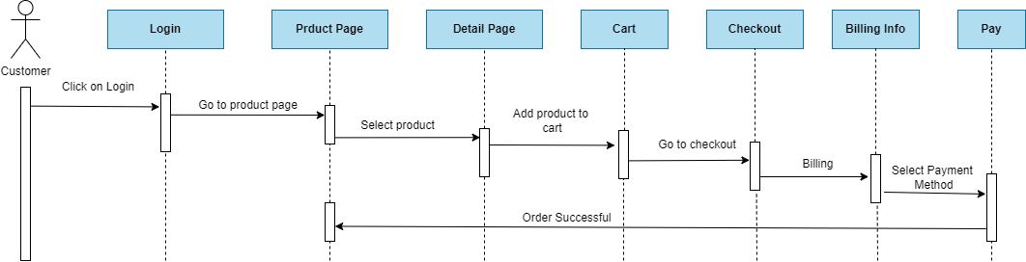

- Logout
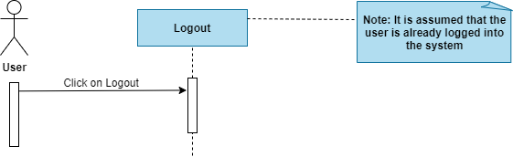

- Add Product
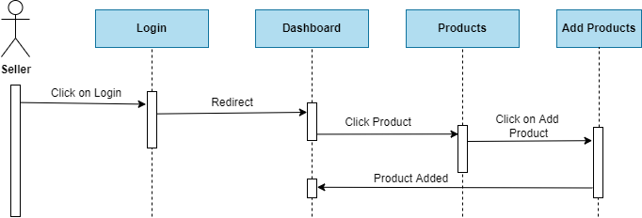

- View Product
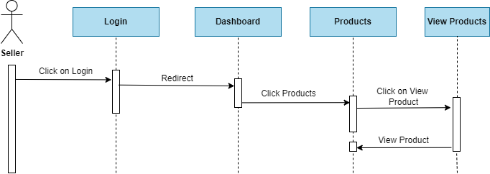
- Update Product
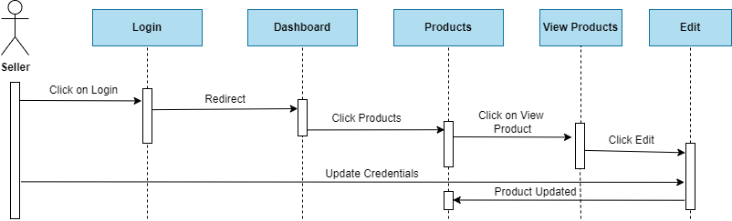
- Delete
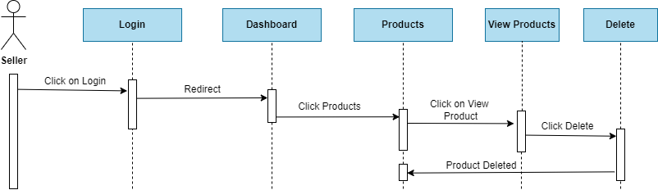
- Approve Products

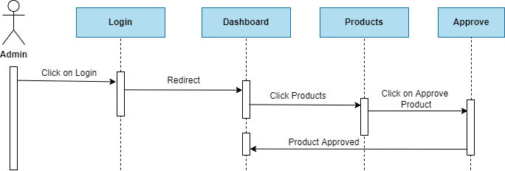

- Approve Seller
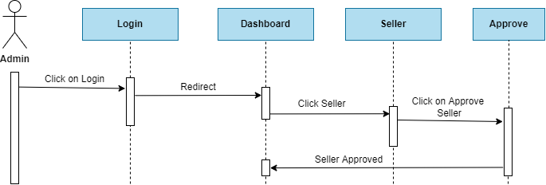
- Delete Seller
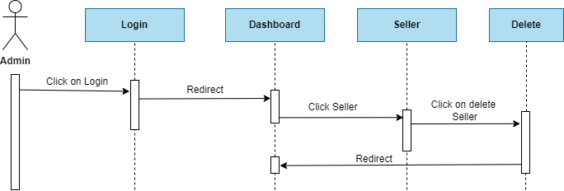

4.7. Activity Diagram
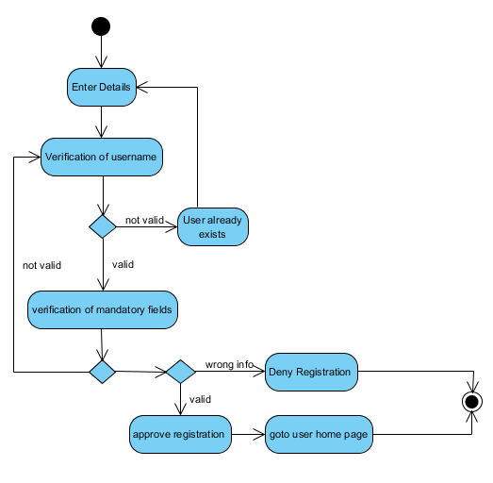
- Registration

- Login
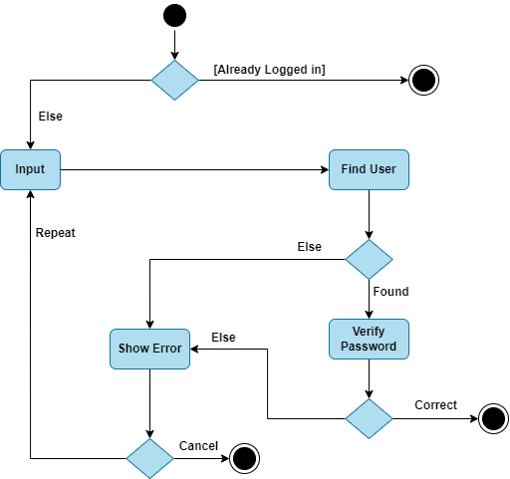

- Add to cart
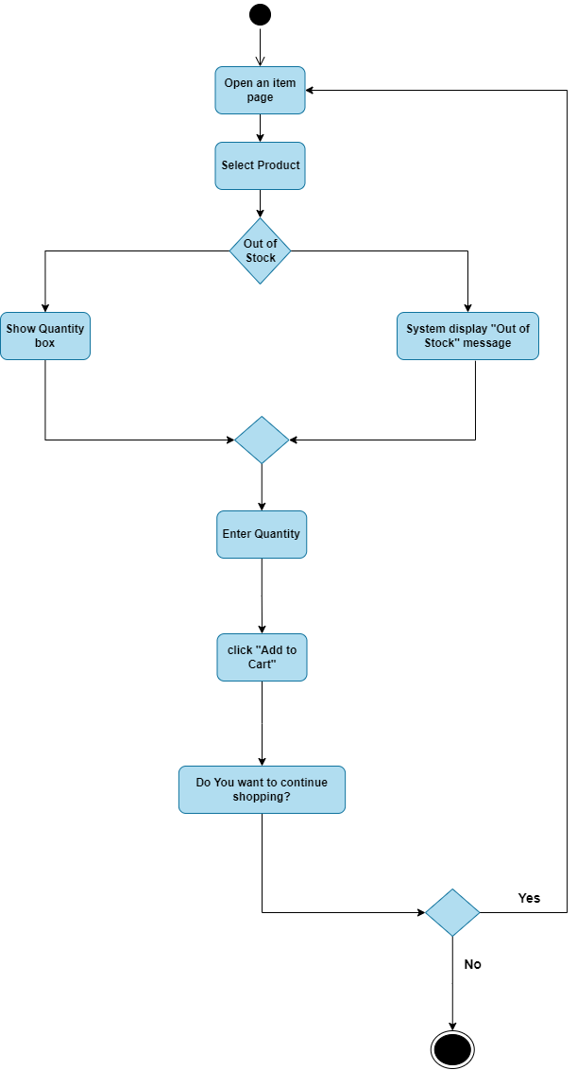

- Remove Product From Cart

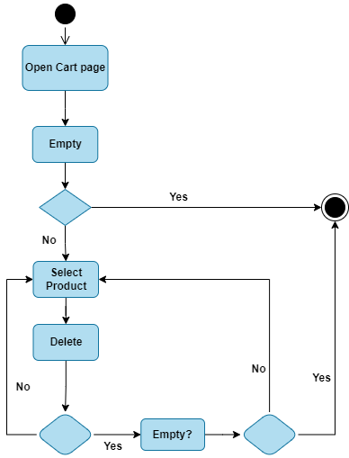

- View Cart Products
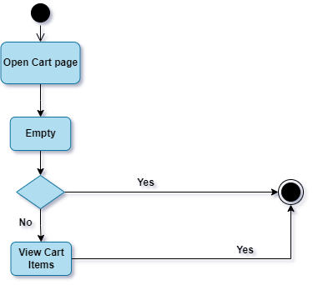

- Payment Gateway
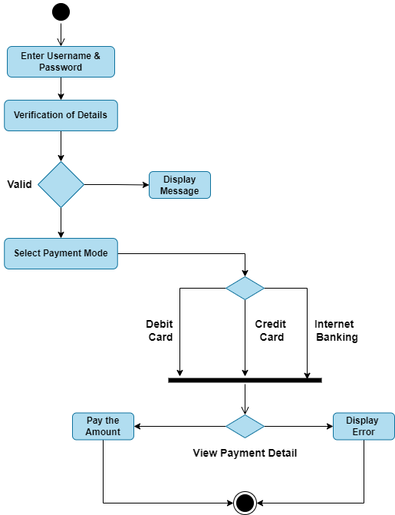

- Add New Stock Product
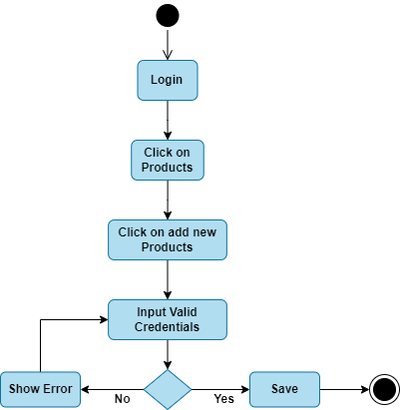

- View Cart
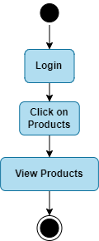

- Customize Product
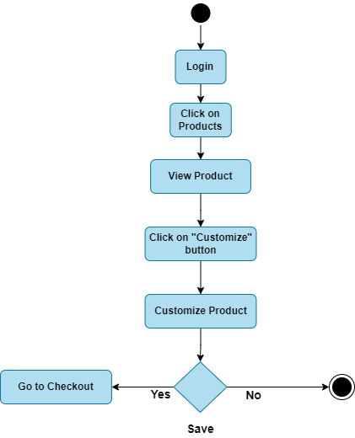
- Delete Product
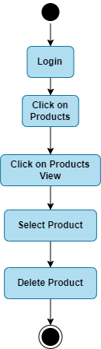

- Process Order
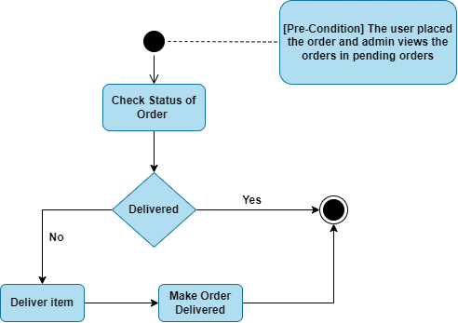

- Logout

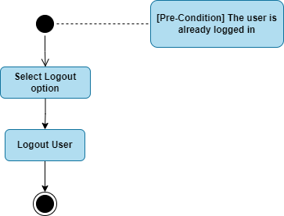

4.8. State Transition Diagram
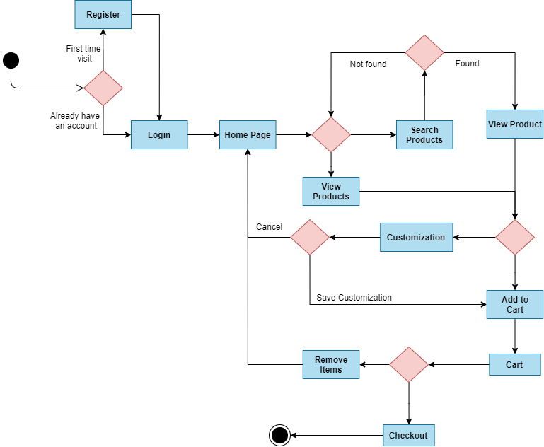

4.9. Component Diagram
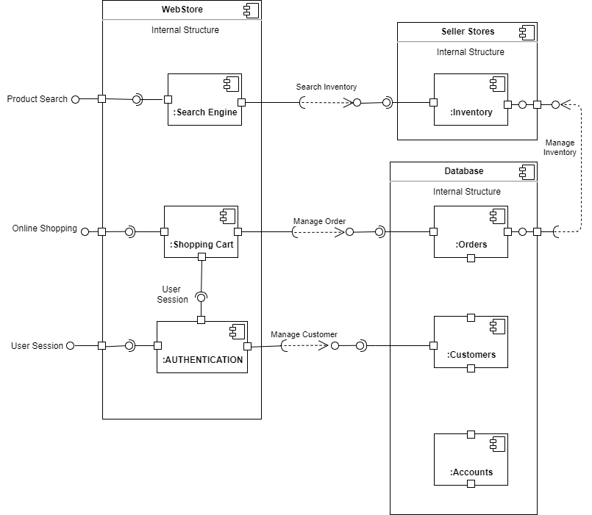

4.10. Deployment Diagram
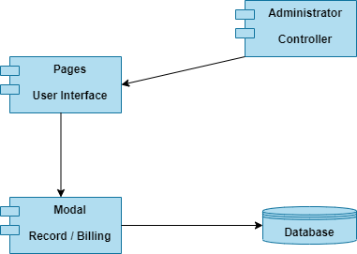

4.11. Data Flow diagram
- Level 0
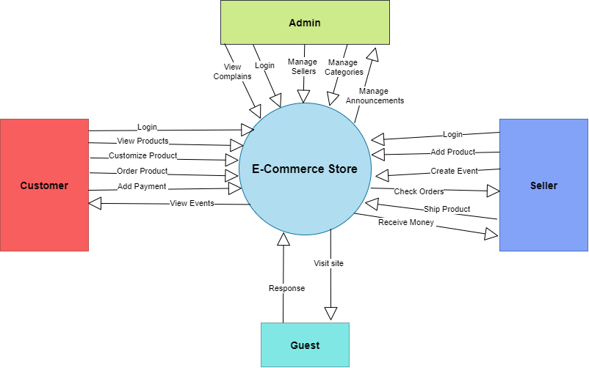
- Level 1
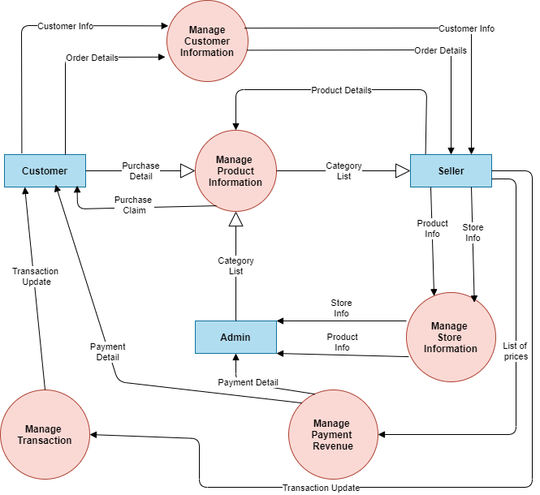

Chapter 5

Implementation

Chapter 5: Implementation
This chapter is all about implementation of tools and techniques, coding standards, flow of program. It should help to understand how much this system is efficient and sufficient to meet functional requirements.

5.2. Components, Libraries, Web Services and stubs
E-Commerce Store is based on Web Development ReactJS and NodeJS Frameworks including Database queries are based on stored procedures, triggers.

5.3. Deployment Environment
Our system required a Web environment to work fully functional. It also can work on mobiles, tablets and all others devices.

5.4. Tools and Techniques
Following tools and techniques which are used:
• HTML
• CSS
• Bootstrap
• ReactJS
- NodeJS
- PgAdmin
- PostgreSQL
• VS Code.

5.5. Best Practices / Coding Standards
PostgreSQL Database, ReactJS and NodeJS coding standards are used to implement E-Commerce Store. ReactJS and NodeJS Framework have some constraints that should fulfill to acquire the accurate results. Code is efficient and can be reused.

5.6. Version Control
We are working on these versions
- ReactJS 17.0
- NodeJS 16.13
- MySql

Chapter 6
Testing and Evaluation

Chapter 6: Testing and Evaluation
Test and Evaluation (T&E) is the interaction by which a framework or parts are looked at against prerequisites and details through testing. The outcomes are assessed to evaluate progress of plan, execution, acceptability, and so on.

6.1 Use Case Testing
Test A :
On app testing run the command “npm run start:dev” , and server will start running and there is no error consoled in app , app is running as aspected
Test B:
For postman testing , run the server on vs code , open any role request and hit send and wait for response , if the body is correct status will be 200 and response will be accurate and in case of bad body it will show the error with reponse 200

6.1.1 Equivalence partitioning
Equivalence Class Partitioning is kind of black box testing procedure which can be applied to all degrees of programming testing like unit, coordination, framework, and so on. In this method, input information units are separated into comparable allotments that can be utilized to determine experiments which decreases time expected for testing due to modest number of experiments.
• It partitions the info information of programming into various proportionality information classes.
• You can apply this strategy, where there is a reach in the info field.

6.1.2 Boundary value analysis
Boundry testing is the method involved with testing between outrageous finishes or limits between segments of the information values.
• So these outrageous closures like Start-End, Lower-Upper, Maximum-Minimum, Just Inside-Just Outside values are called limit values and the testing is classified "limit testing".
• The essential thought in typical limit esteem testing is to choose input variable qualities at their:
- Minimum
- Just above the minimum
- A nominal value
- Just below the maximum
- Maximum

6.2 Data flow testing
Information Flow Testing is a sort of underlying testing. A strategy is utilized to track down the test ways of a program as per the areas of definitions and utilizations of factors in the program. It doesn't have anything to do with information stream outlines

Unit testing
UNIT TESTING is a sort of programming testing where individual units or parts of a product are tried. The design is to approve that every unit of the product code proceeds true to form. Unit Testing is finished during the turn of events (coding period) of an application by the engineers.

Integration testing
Mix testing - - otherwise called combination and testing (I&T) - - is a kind of programming testing in which the various units, modules or parts of a product application are tried as a consolidated substance. In any case, these modules might be coded by various software engineers.

Performance testing
Performance testing is a trying measure that assesses the speed, responsiveness and security of a PC, organization, programming system or gadget under a responsibility. Associations will run execution tests to distinguish execution related bottlenecks.

Stress Testing
Stress testing is the most common way of deciding the capacity of a PC, organization, program or gadget to keep a specific degree of viability under negative circumstances. The cycle can include quantitative tests done in a lab, for example, estimating the recurrence of mistakes or framework crashes.

Chapter 7
Summary, Conclusion and Future Enhancements

Chapter 7: Summary, Conclusion & Future Enhancements

7.1 Project Summary
Internet Shopping is a way of life online business web application, which retails different style and way of life items. This task permits seeing different items accessible empowering enlisted clients to buy wanted items quickly utilizing different installment process, and furthermore can put in a request by utilizing the Cash on Delivery (Pay Later) choice. This venture gives simple admittance to Administrators and Managers to see orders put utilizing Pay Later and Instant Pay choices.
To foster an online business site, various Technologies should be considered and perceived. These incorporate multi-layered engineering, server, and client-side prearranging methods, and execution innovations like React.JS, Node.JS, and social data sets. This is a task with the target to foster an essential site where a purchaser is furnished with a shopping basket application and furthermore to realize about the innovations used to foster such an application.

7.2 Achievements and Improvements
Progresses in the advanced economy have pushed makers, particularly those in the data innovation (IT) industry, to imagine items that shoppers can alter to meet their own particular requirements. This study inspects the systems of organizations to offer such adjustable items to purchasers. Our investigation shows that an imposing business model organization acquires benefit by offering an adjustable item to the shopper than by offering a normalized item that is pre-designed provided that the purchasers are adequately ready to play out the undertaking of personalization; in any case it is more beneficial for the organization to offer a normalized item. Likewise, purchasers get a bigger excess when the organization offers adjustable items. We likewise consider the situation where the organization can offer both a versatile item and a normalized item and find that the organization helps more from offering the two items than from offering either item, as the flexibility and the purchaser variation costs are not excessively high. Strangely, when the organization offers the two items, its endeavors to further develop customer personalization (e.g., offering free purchaser preparation) consistently benefit both the organization and shoppers. (Gu, 2015)

7.3 Critical Review
The world we see today is becoming more and more digital. In this digitized world, e-commerce is taking over by bringing products within reach of customers where the customer no longer has to leave the house. As people today depend on products online, the importance of a review is becoming increasingly important. To select a product, a customer has to go through thousands of reviews to understand a product. But in this thriving day of machine learning, it would be much easier to search through thousands of reviews if a template were used to polarize and learn from those reviews. We used the guided learning method on a large-scale Amazon dataset to polarize it and achieve satisfactory accuracy. (Haque, 2018, May)

7.4 Future Enhancements/Recommendations
E-Commerce Store is pointed towards the merchants who need to connect with the most extreme cross section of client and ordinary citizens who can be likely client. This venture conceives overcoming any issues between the dealer, the retailer and the client. OFS (make available for purchase) ought to be easy to use, 'fast to learn' and solid programming for the above reason. OFS is planned to be an independent item and shouldn't rely upon the accessibility of other programming. It ought to run on both UNIX and Windows based platform.

